LAB-24.1(AIAC)
Ch .Tejaswi
2303A51944
B27
Task 1 – Environment Setup OUTPUT:
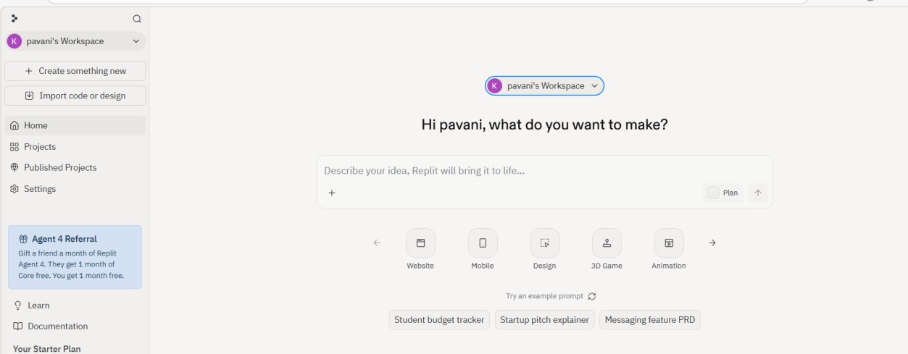
EXPLANATION:
- created a free account on Replit and successfully accessed the workspace dashboard.
- I explored the available project templates for mobile and web app development.
- The environment is now ready to create and run projects.

Task 2 – Basic Mobile App

PROMPT:
Build a simple “Hello App” with a title, a text input for the user’s name, and a button. When the button is clicked, display a greeting message like “Hello, [Name]” dynamically.
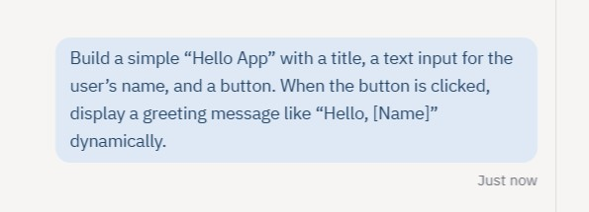

CODE:
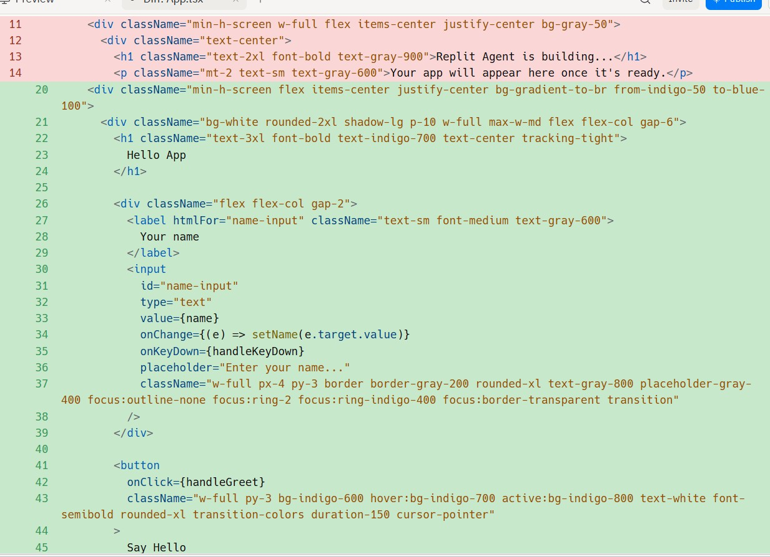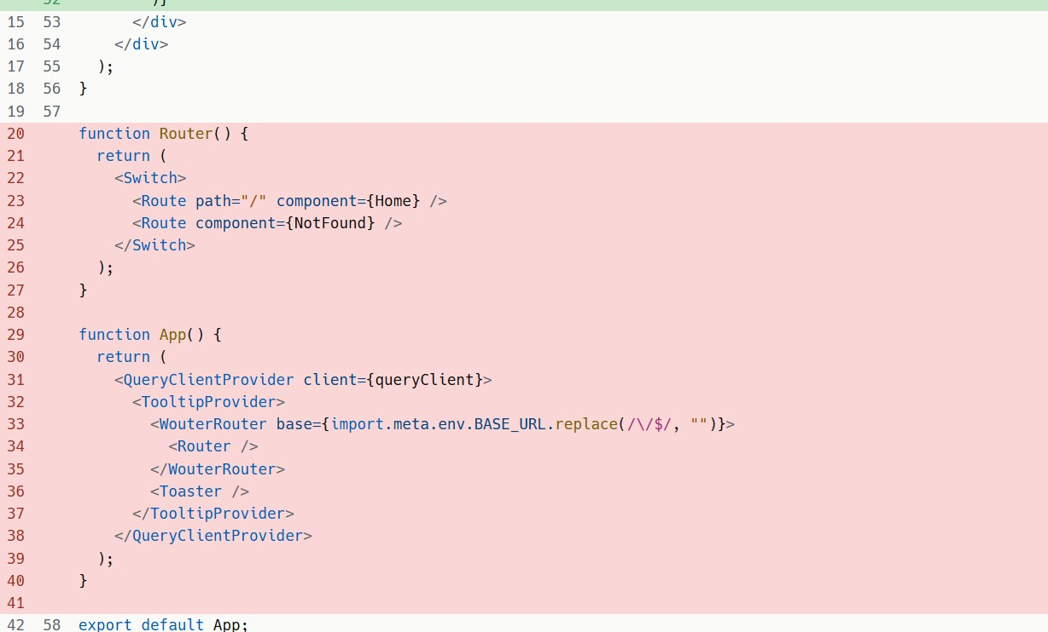
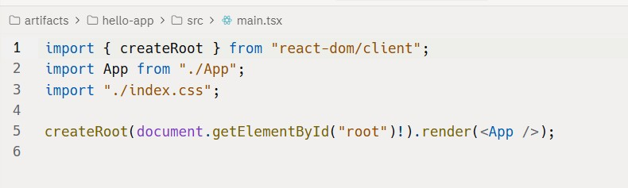
OUTPUT:
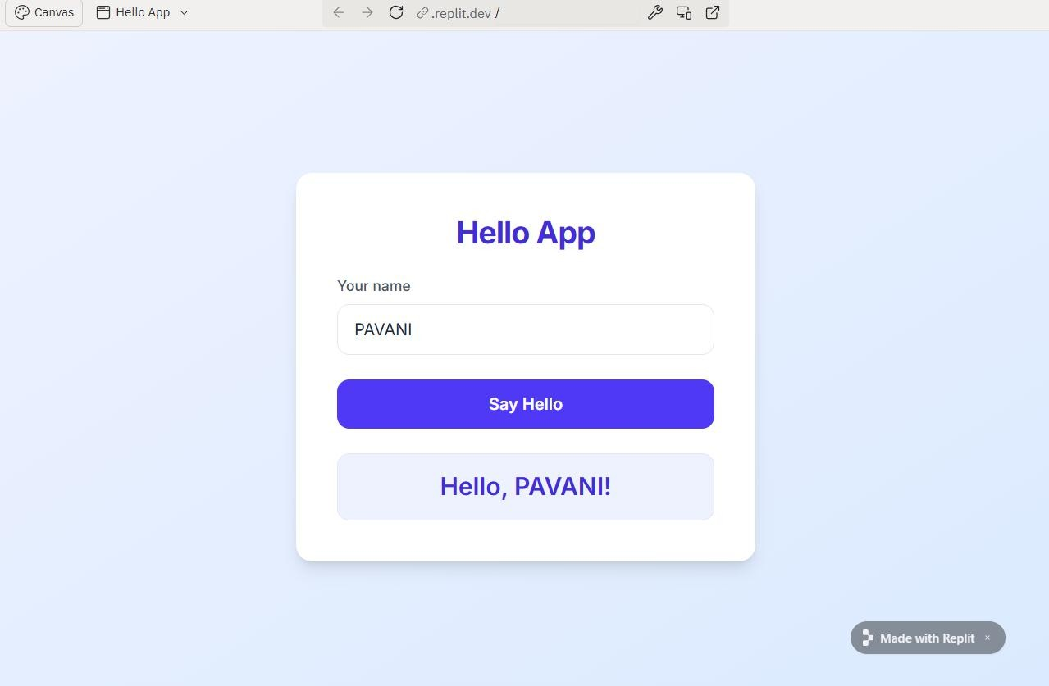

EXPLANATION:
- A simple Hello App is built with a title, an input field for the user’s name, and a button to display a dynamic greeting message.
- AI assistance is used to generate the boilerplate code and explain the basic structure of the application.
- This helps in understanding how different components of the app work together.
Task 3 – Adding Features with AI Assistance PROMPT:
Enhance the existing app by adding a navigation bar with Home, About, and Contact pages, along with a user registration form that handles input and submission. Apply basic styling using CSS to improve the UI. Also, generate clear inline comments for each function to explain its purpose and functionality.
CODE:
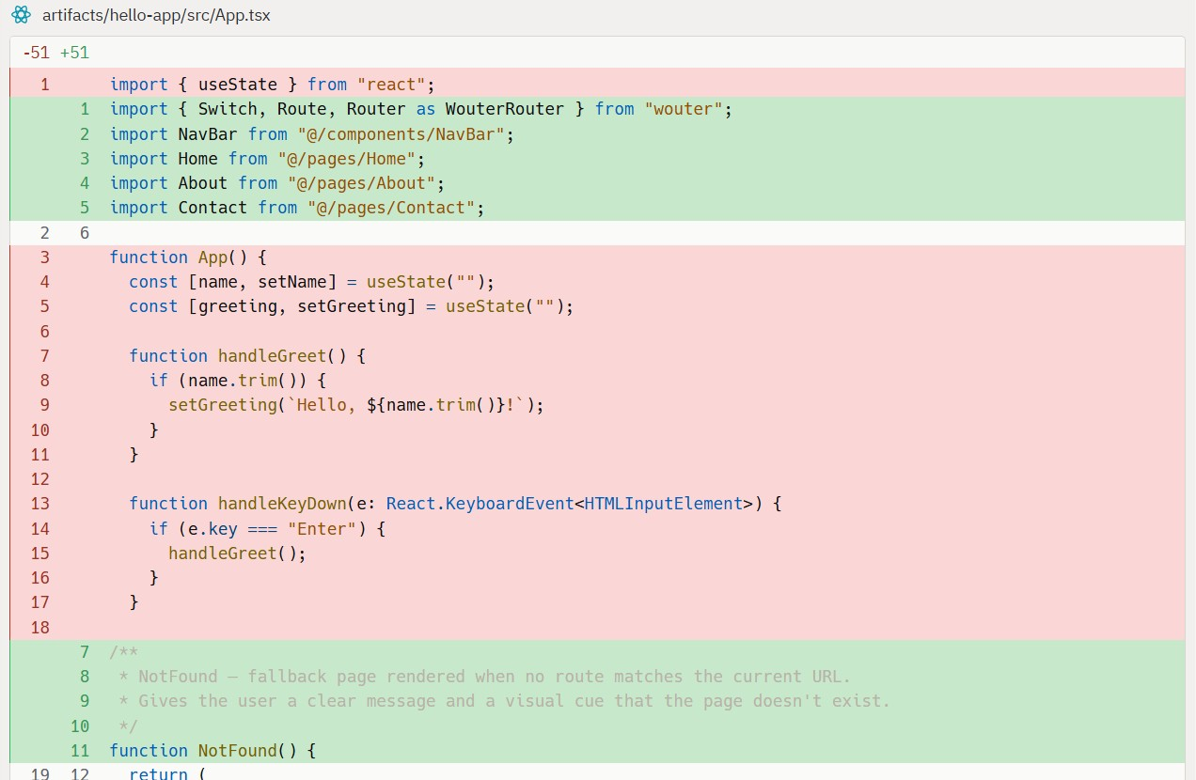
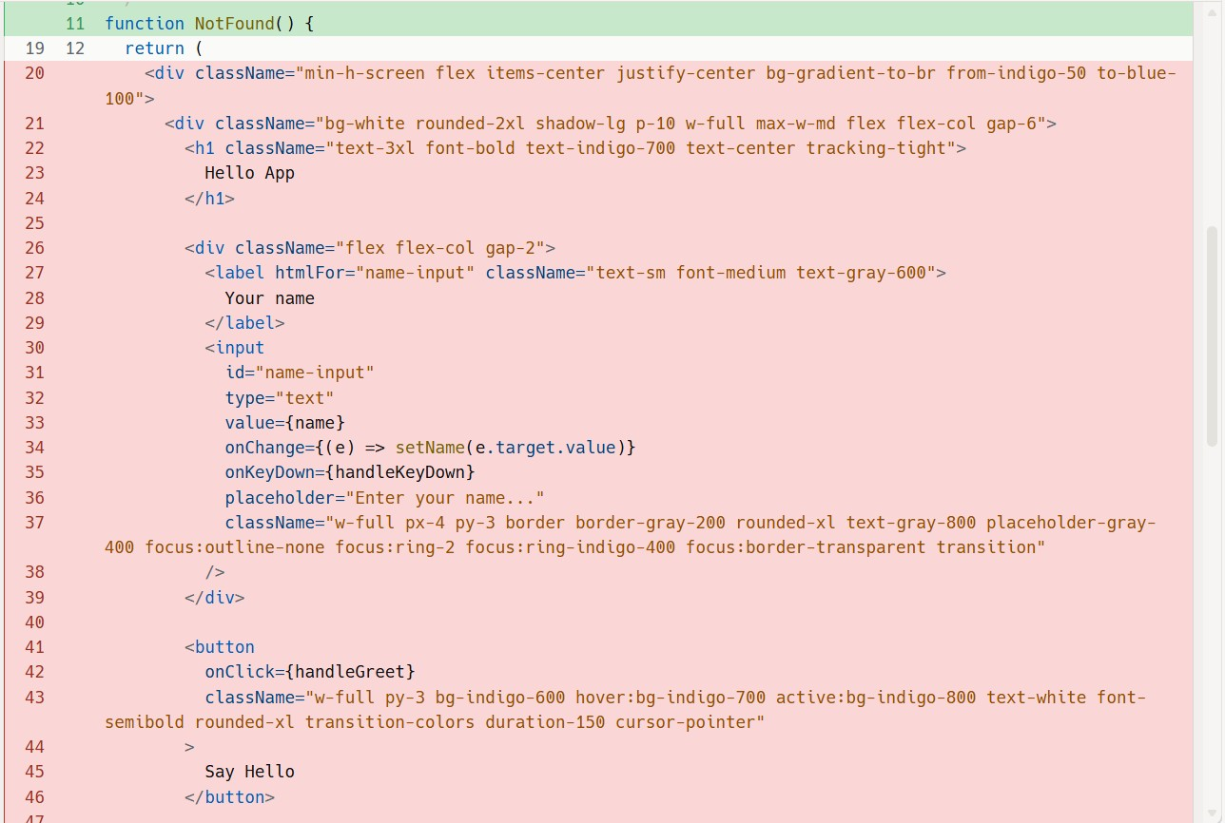

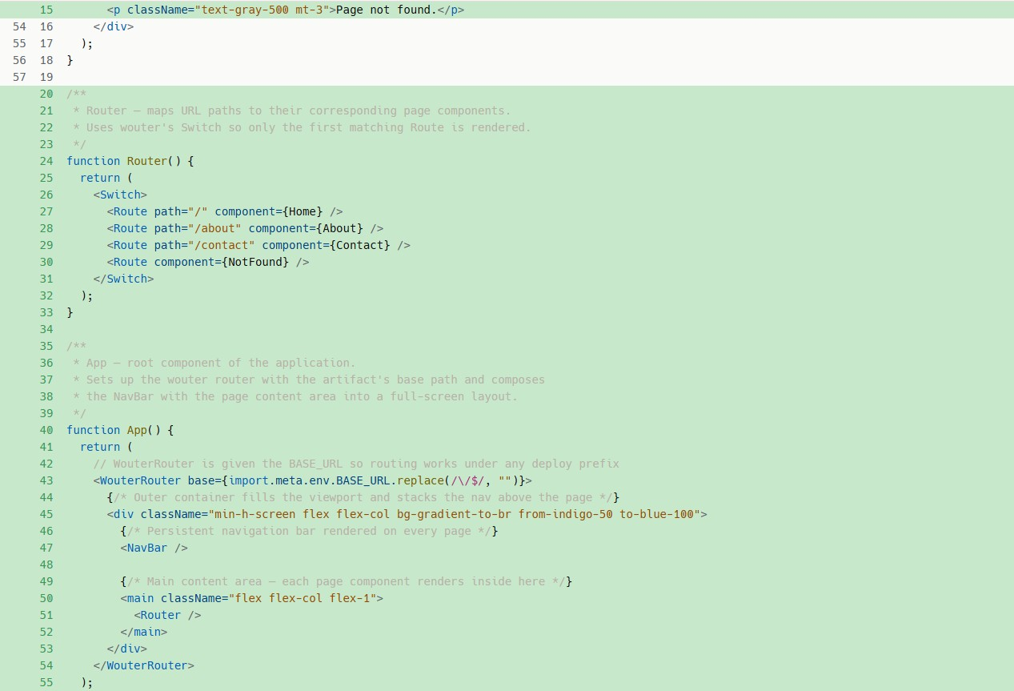

OUTPUT:
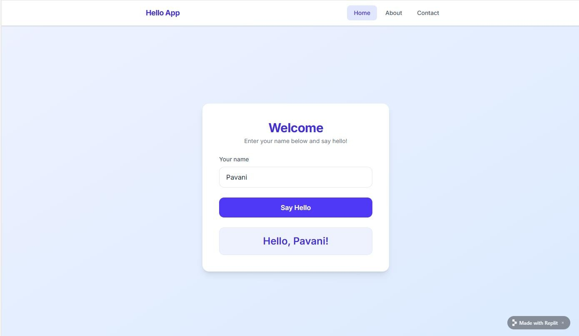
EXPLANATION:
- The application is enhanced by adding a navigation bar, a user registration form, and basic styling to improve the user interface.
- Form handling is implemented to capture and process user input effectively.
- AI assistance is used to add inline documentation, making the code easier to understand and maintain.

Task 4 – Testing on Mobile PROMPT:
Run the application in Replit’s mobile preview mode and test its responsiveness across different screen sizes. Identify any UI alignment or layout issues and suggest improvements. Use AI assistance to fix these issues and ensure a clean, mobile-friendly design.
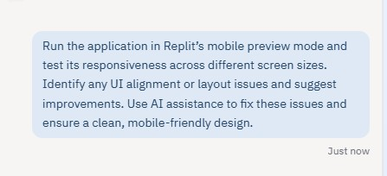
CODE:
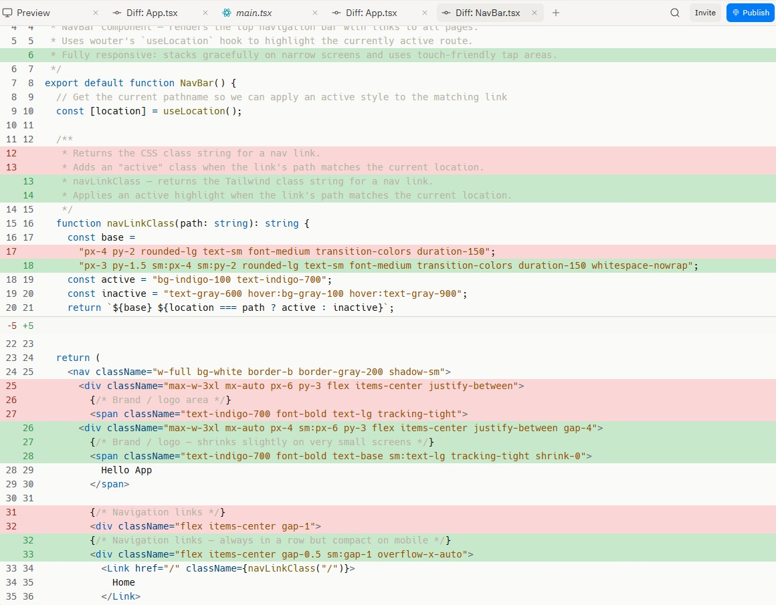
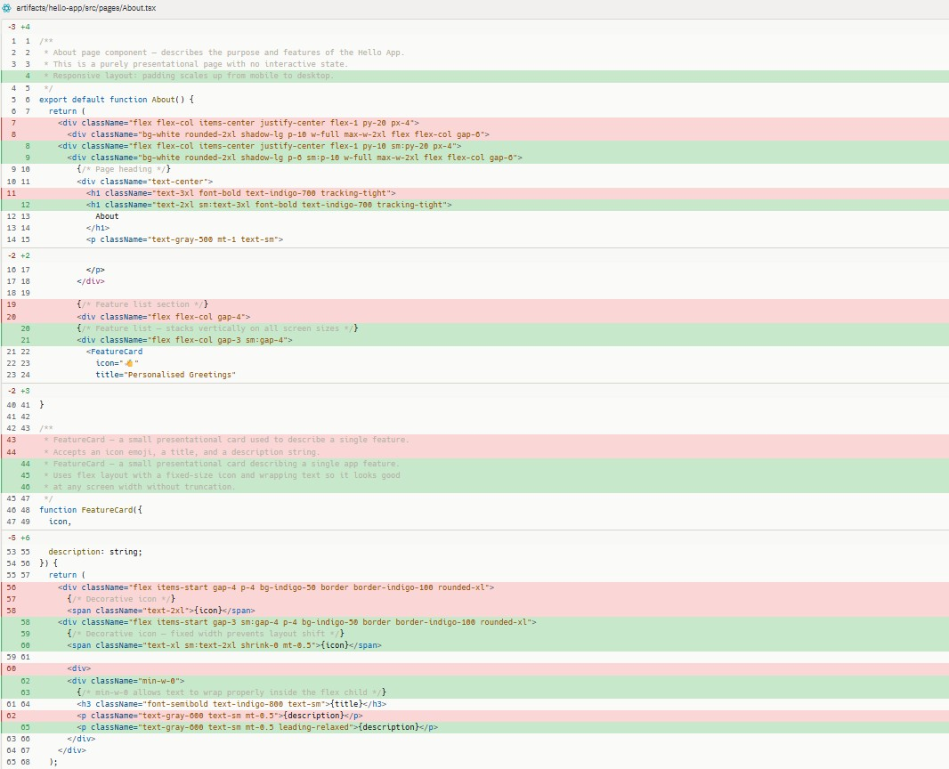

OUTPUT:
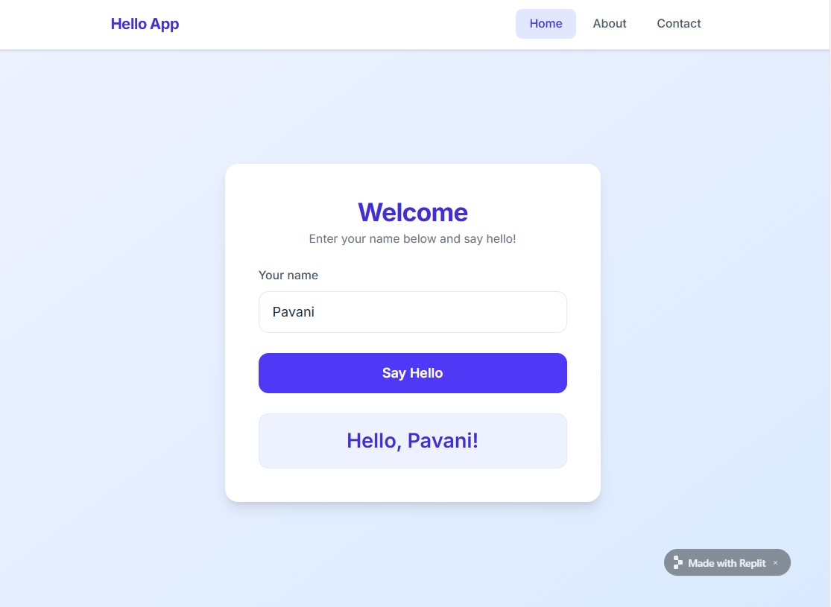
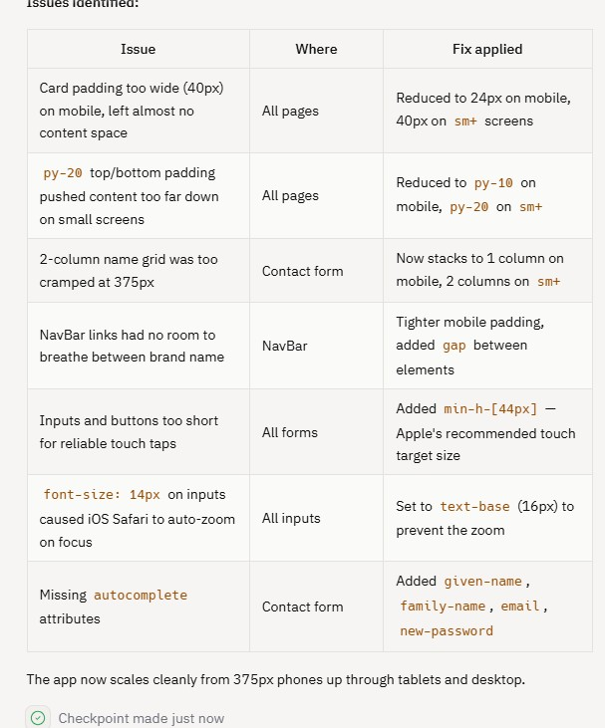

EXPLANATION:
- The application is tested in Replit’s mobile preview mode to ensure it works smoothly on different screen sizes.
- UI alignment and layout issues are identified during testing.
- AI assistance is used to fix these issues and improve responsiveness for a better user experience.

Task 5 – Deployment PROMPT:
Deploy the application using Replit hosting or export it to a mobile framework like Expo (for React Native). Generate a shareable deployment link and ensure the app runs smoothly for external users. Also, summarize the learning outcomes, including using Replit for development, building a functional app with UI and navigation, and gaining experience with AI-assisted coding, debugging, and documentation.
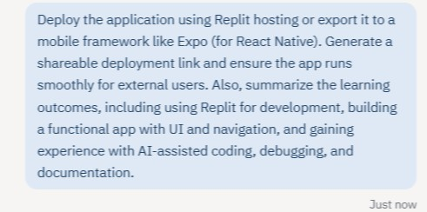
OUTPUT:
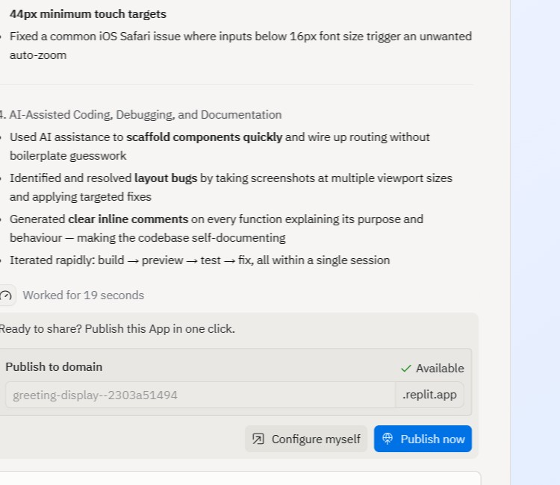


EXPLANATION:
- The application is deployed using Replit hosting or exported to a mobile framework to make it accessible online.
- The deployment link is shared with others for testing and feedback.
- This task helps in understanding app deployment, building functional mobile applications, and gaining experience with AI-assisted development, debugging, and documentation.

